Part 1:

1. <https://www.telework.gov>
2. Telework.gov
3. The target audience for the website is government employees that work from home or an alternate worksite.
4. 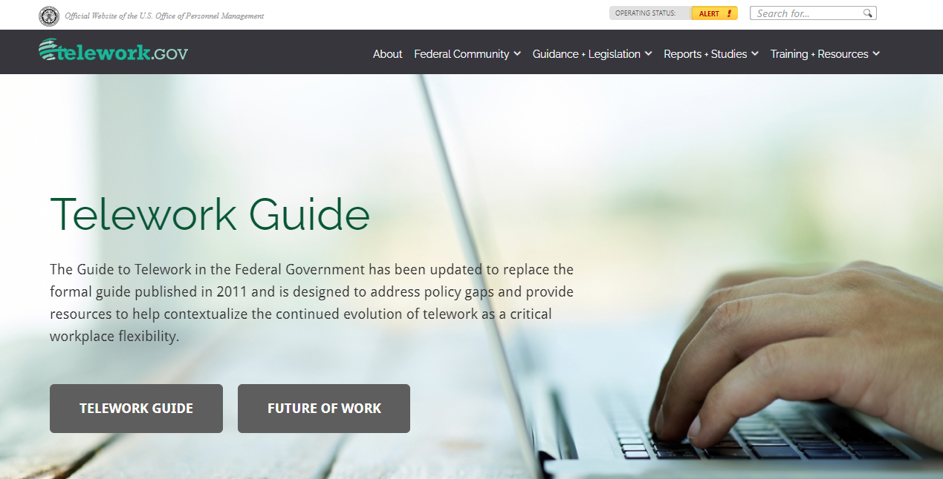
5. It has a navigation bar that uses dynamic navigation, it uses a breadcrumb trail for different things in the navigation bar, and it offers a site search feature.
6. Repetition is used most frequently in the font used and the changing of color for the links. Contrast is used when the background color would clash with the font color, like when the font color is white instead of black on the teal background. Proximity seems to be the most used thing on the web page, with the home page separated by different colors and containing things that are similar to each other in the different colored areas. Alignment is seen where the different paragraphs line up in the separate colored sections and with the buttons on the first section the user sees.
7. X = has

| **Page Layout Criteria** |
| --- |
| □X  1. Consistent site header/logo |
| □X  2. Consistent navigation area |
| □X  3. Informative page title that includes the company/organization/site name |
| □X  4. Page footer area—copyright, last update, contact e-mail address |
| □X  5. Good use of basic design principles: repetition, contrast, proximity, and alignment |
| □X  6. Balance of text/graphics/white space on page |
| □X  7. Home page downloads within 10 seconds on a mobile device |
| □X  8. Viewport meta tag is used to enhance display on smartphone |
| □X  9. Responsive page layout is configured for smartphone and tablet display |
| **Navigation Criteria** |
| □X  1. Main navigation links are clearly and consistently labeled |
| □ X 2. Navigation is structured within an unordered list |
| □X  3. When the main navigation consists of images and/or multimedia, the page footer area contains plain text hyperlinks (accessibility) |
| □ X 4. Navigational aids, such as site map, skip to content link, or breadcrumbs, are used |
| **Color and Graphics Criteria** |
| □ X 1. Use of different colors is limited to a maximum of three or four plus neutrals |
| □ X 2. Color is used consistently |
| □ X 3. Background and text colors have good contrast |
| □ X 4. Color is not used alone to convey meaning (accessibility) |
| □ X 5. Use of color and graphics enhances rather than distracts from the site |
| □ X 6. Graphics are optimized and do not slow download significantly |
| □ X 7. Each graphic used serves a clear purpose |
| □ X 8. Image elements use the alt attribute to configure alternate text (accessibility) |
| □ X 9. Animated images do not dist |

| **Multimedia Criteria** |
| --- |
| □ X 1. Each audio or video file used serves a clear purpose |
| □ X 2. The audio or video files used enhance rather than distract from the site |
| □ X 3. Captions or transcripts are provided for each audio or video file used (accessibility) |
| □ X 4. The file size is indicated for audio and video downloads |
| **Content Presentation Criteria** |
| □ X 1. Common fonts such as Arial or Times New Roman are used |
| □ X 2. Techniques of writing for the Web are applied: headings, subheadings, bulleted lists, short sentences in brief paragraphs, use of empty space |
| □ X 3. Fonts, font sizes, and font colors are consistently used |
| □ X 4. Content provides meaningful, useful information |
| □ X 5. Content is organized in a consistent manner |
| □ X 6. Information is easy to find (minimal clicks) |
| □ X 7. Timeliness: The date of the last revision and/or copyright date is accurate |
| □ X 8. Content is free of typographical and grammatical errors |
| □ X 9. Avoids the use of “Click here” when writing text for hyperlinks |
| □ X 10. Hyperlinks use a consistent set of colors to indicate visited/nonvisited status |
| □  11. Alternate text equivalent of content is provided for graphics and media (accessibility) |
| **Functionality Criteria** |

| □ X 1. All internal hyperlinks work |
| --- |
| □ X 2. All external hyperlinks work |
| □ X 3. All forms function as expected |
| □ X 4. No error messages are generated by the pages |
| **Additional Accessibility Criteria** |
| □ X 1. Use attributes designed to improve accessibility such as alt and title where appropriate |
| □ X 2. The html element’s lang attribute indicates the spoken language of the page |
| **Browser Compatibility Criteria** |
| □ X 1. Displays on current versions of Edge, Internet Explorer, Firefox, Safari, Chrome, and Opera |
| □ X 2. Displays on popular mobile devices (including tablets and smartphones) |

1. A way to listen to the web page instead of reading it. Make the background picture get smaller when the screen size is increased or decreased. Add a explanation under the pictures of people instead of links to the positions it says.

Part 2:

1. <https://codeclimate.com/>
2. Code Climate
3. The target audience is people looking to manage teams of software developers.
4. 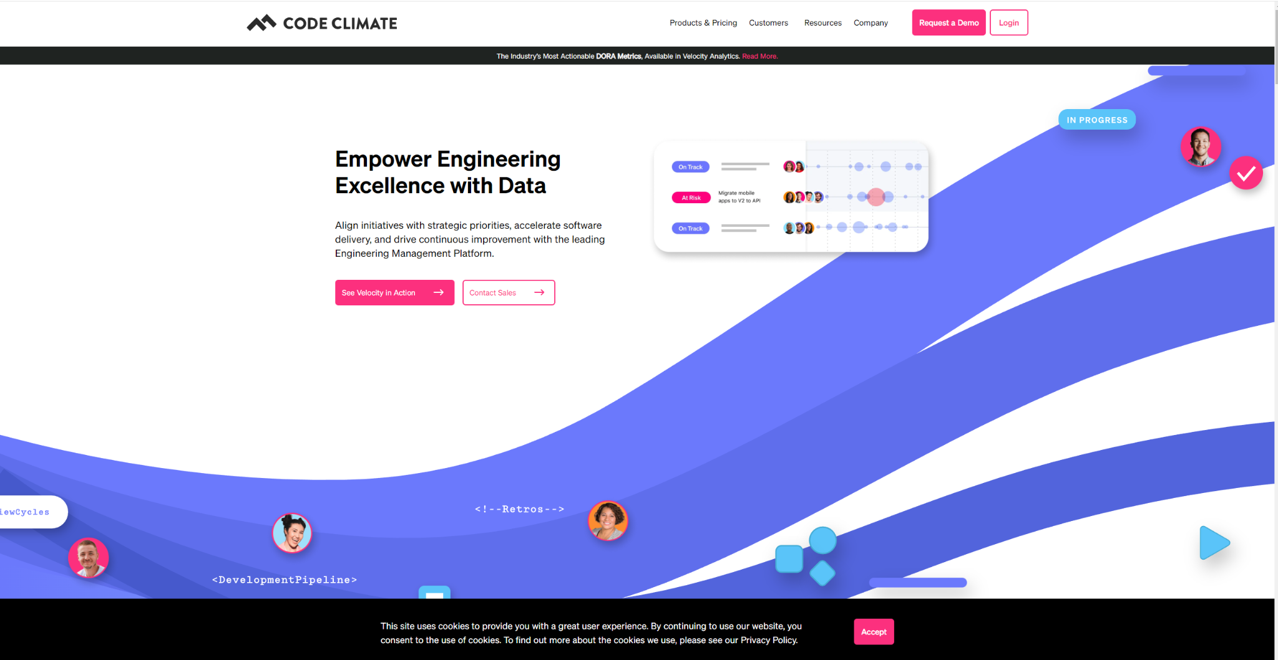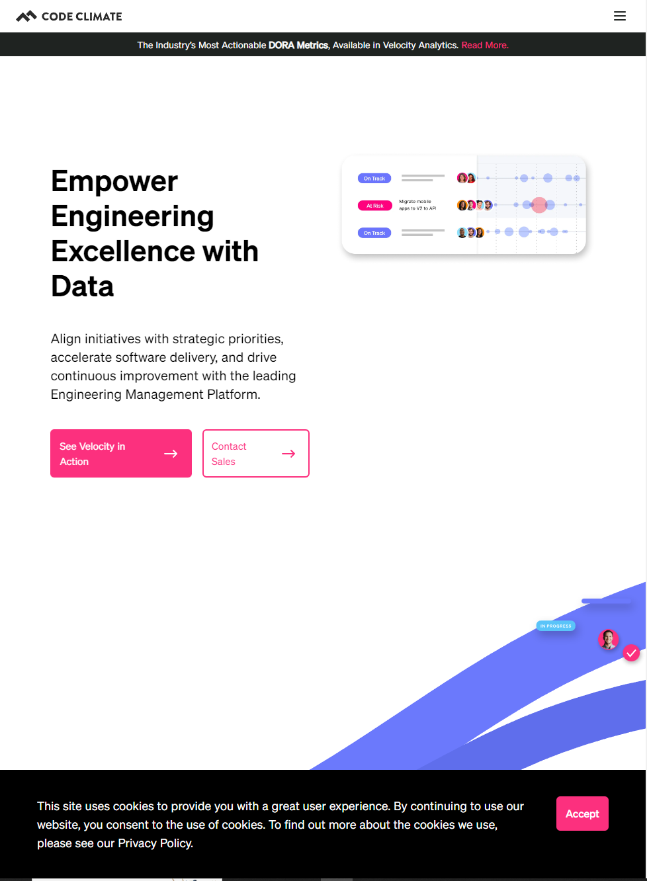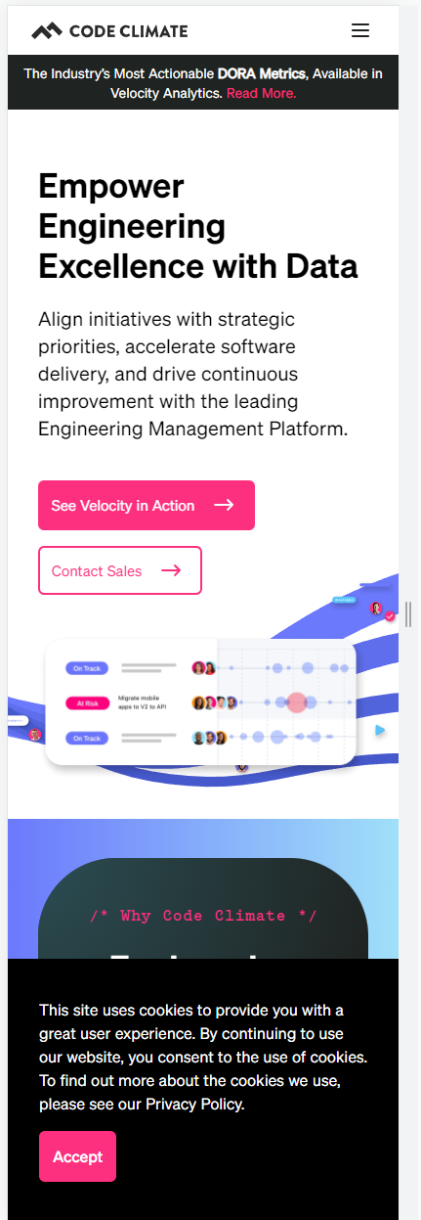
5. The background is moved bellow the first paragraph in the tablet and smartphone views. The picture with the tracking example is moved to below the first paragraph on the smartphone view. The font remains the same, but the font size seems to change. The proximity of things changes across the views. The thing where what is displayed changes as you scroll down is only on the computer view.
6. Everything was moved to be linear and condensed into a single line stream of information. The font seems to have been made a tad bit bigger than the other views.
7. No, it does not meet the needs on the phone view. The phone view puts everything in a line, which forces phone users to scorll through the site longer than it would on a PC or a tablet, which could cause potential customers to leave the site before reading everything.